# ASSIGNMENT

Select 3 LLM Tools:

* Claude
* Gemini
* Chat GPT

Use the same 3 prompts on all three tools:

1. Summarize a 500-word article into exactly 5 bullet points

|  |  |  |  |  |
| --- | --- | --- | --- | --- |
| Tool | Response Clarity | Accuracy | Creativity | Speed |
| Claude | is clear but less polished in presentation | Claude generically says "Pacific Northwest millipedes" without the species name |  | 8 seconds |
| Gemini | has good clarity but lacks the scientific precision and formatting that makes information easy to scan | Good core accuracy but missing supporting details |  | 5 seconds |
| Chat GPT | has the clearest structure with proper formatting, bold emphasis on key terms, and consistent citation format | ChatGPT correctly mentions the previous research was on "Ishcnocybe plicata" from the Pacific Northwest |  | 6 seconds |

Claude – Find any 500-word article on any topic from the internet –   
Gave resources but not the links of all the resources - This took longer because I used web search and web fetch tools multiple times

Please give the links   
Couldn’t find the links

1. Write a python code to scrape headlines from a news website

|  |  |  |  |  |
| --- | --- | --- | --- | --- |
| Tool | Response Clarity | Accuracy | Creativity | Speed |
| Claude | Highly Complex | Accurate but extremely complex, could have errors and bug handling issues. |  | 33 seconds |
| Gemini | Complex | Highly accurate in terms of real world application and understandability. |  | 16 seconds |
| Chat GPT | Much compact, easy to understand code | Most accurate in terms of understandability, but could fail in real world implementation |  | 7 seconds |

1. Translate a paragraph into Marathi with cultural sensitivity.

|  |  |  |  |  |
| --- | --- | --- | --- | --- |
| Tool | Response Clarity | Accuracy | Creativity | Speed |
| Claude | Very clear, smooth Marathi, easy to understand. | Accurate to the original meaning, but not word-for-word – it smartly localizes concepts. | High. Claude uses idiomatic and poetic Marathi that resonates culturally, especially with rural readers. It doesn’t just translate but adapts the emotional tone. | 27 seconds |
| Gemini | Clear and grammatical. Slightly more formal tone | Accurate overall, but slightly more literal. | Moderate. It adds some richness | 3 seconds |
| Chat GPT | Clear, smooth, easy to follow. | Accurate, maintains the intended meaning. | Balanced but a little safer. It uses culturally relevant terms | 8 seconds |

* Fact-Checking and Reliability Test

1. Ask each tool 3 factual questions which is publicly verifiable. Check Google if it is correct or not. Note if the tool gives confident but wrong answers.

|  |  |  |  |  |
| --- | --- | --- | --- | --- |
|  | Question | Response | Correctness | Confidence Level |
| Claude | What is the population of India | 1.46 billion | High | High |
| Gemini | What is the population of India | 1.46 billion | High | High |
| Chat GPT | What is the population of India | 1.46 billion | High | High |

* Coding assistance challenge

**Claude:**

Code given by claude:

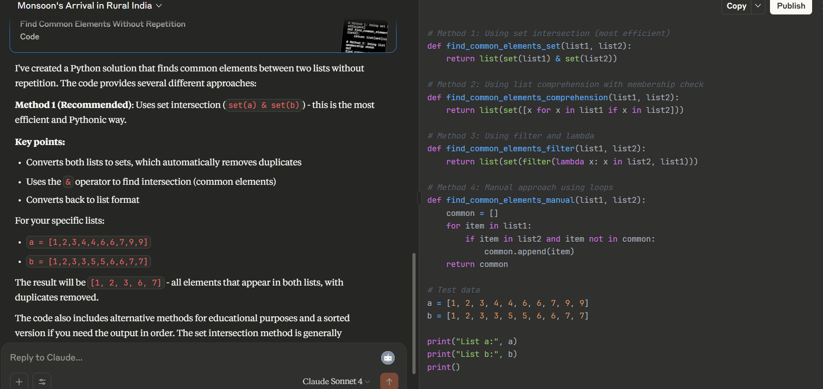

Code run in Jupyter:

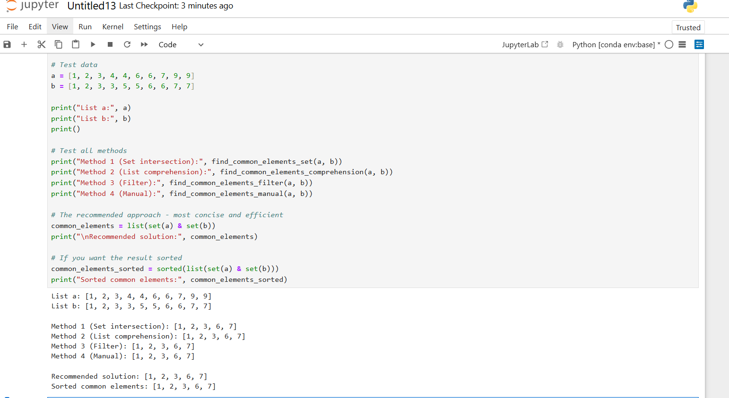

**Gemini:**

**Code given by gemini:**

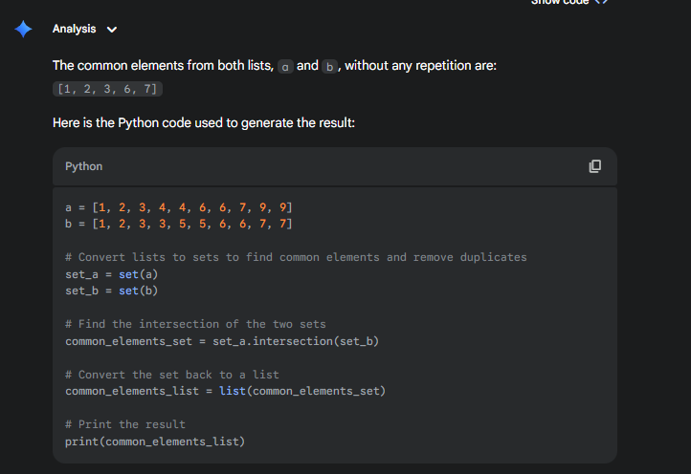

**Code run:**

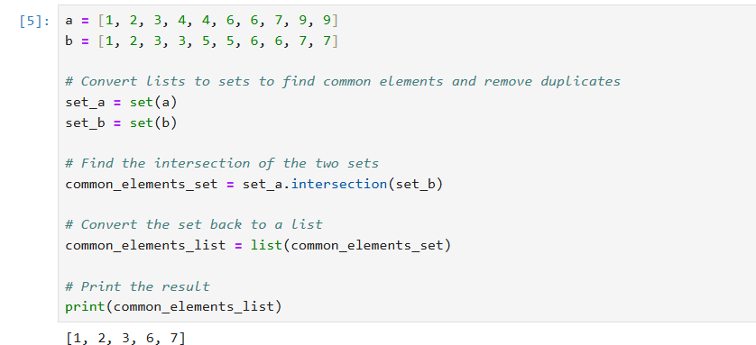

**Chat GPT:**

Code given by chat gpt:

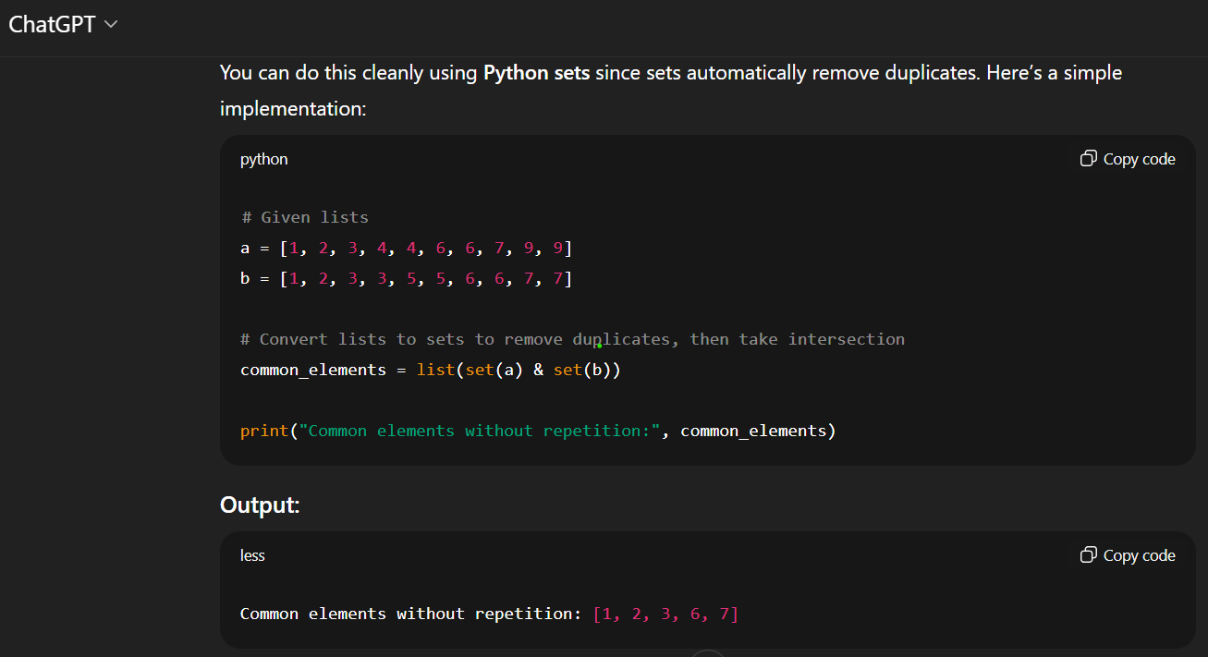

Code run and output  
